ISSACK WAITHAKA
cs-sa07-24085

Introduction to Metasploit
- Metasploit is a penetration testing platform that enables you to write, test and execute the exploit code

- Metasploit framework tools can be used to test for security vulnerabilities, Enumerate networks, execute attacks and evade detection
- Msfconsole is the most popular interface for Metasploit framework
- Data, Documentation, lib are base files for the framework
- Plugins are more flexible since they can be manually or automatically loaded as needed to provide extra functionality

Questions
1.

2.
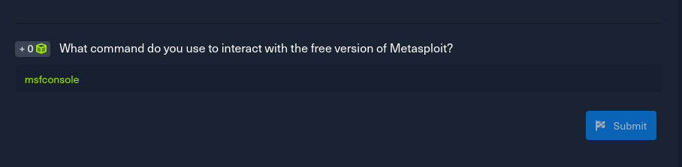

Introduction to Msfconsole
- mf console is the command we to interact with Metasploit Framework
- Help command provide us with the available commands
- We need to search for a suitable exploit based on our target

Modules
- These are prepared scripts with a specific purpose and functions which have already been tested
- Index no is used to select the exploit we want during our searches
- Type is the first segregation between Metasplout modules
- Os specifies which operating system the module was created for
- Service refers to the vulnerable service that is running on the target machine
- Name explain the actual action to be performed using the module
- we can also search for modules using the search command

Questions
a) First we start metasploit and search for the exact exploit name and got the following results
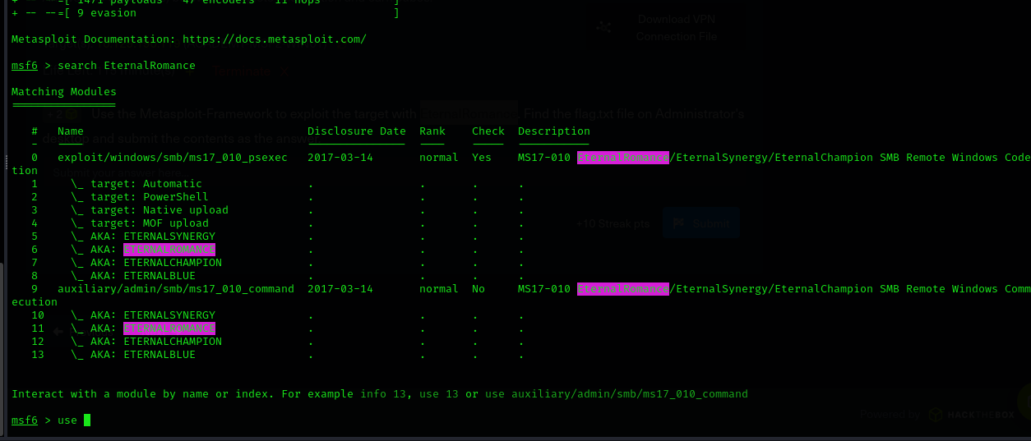
b. We select the index number with the exploit we want to use
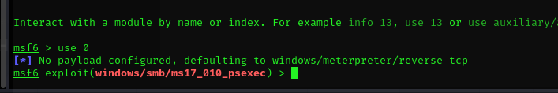
c. We use options to see the options that needed to be set
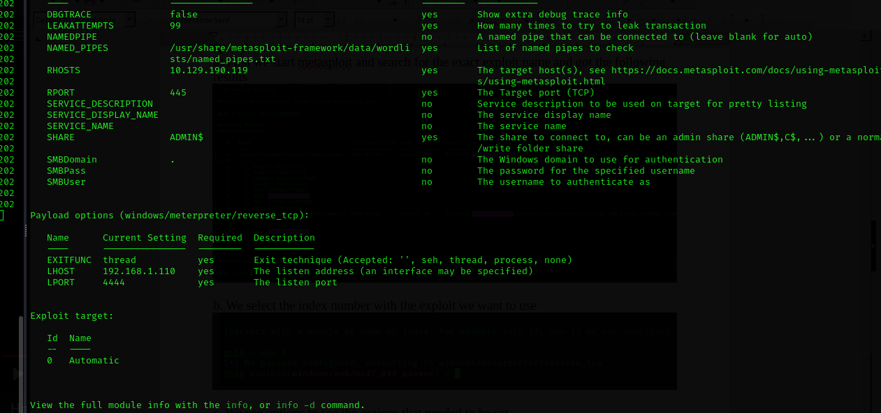
d. We configure the exploit setting the rhost (target) and the lhost (listening interface)
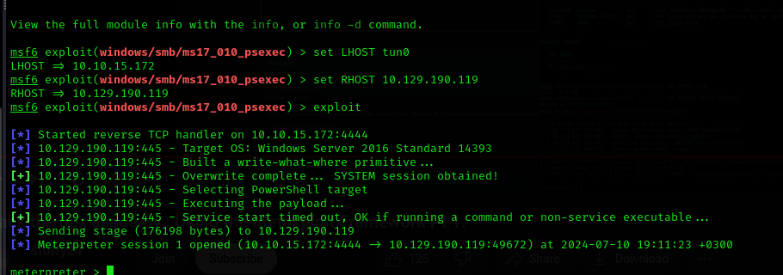
e) I was able to gain access to windows machine and navigated to the administrators desktop where the flag file was
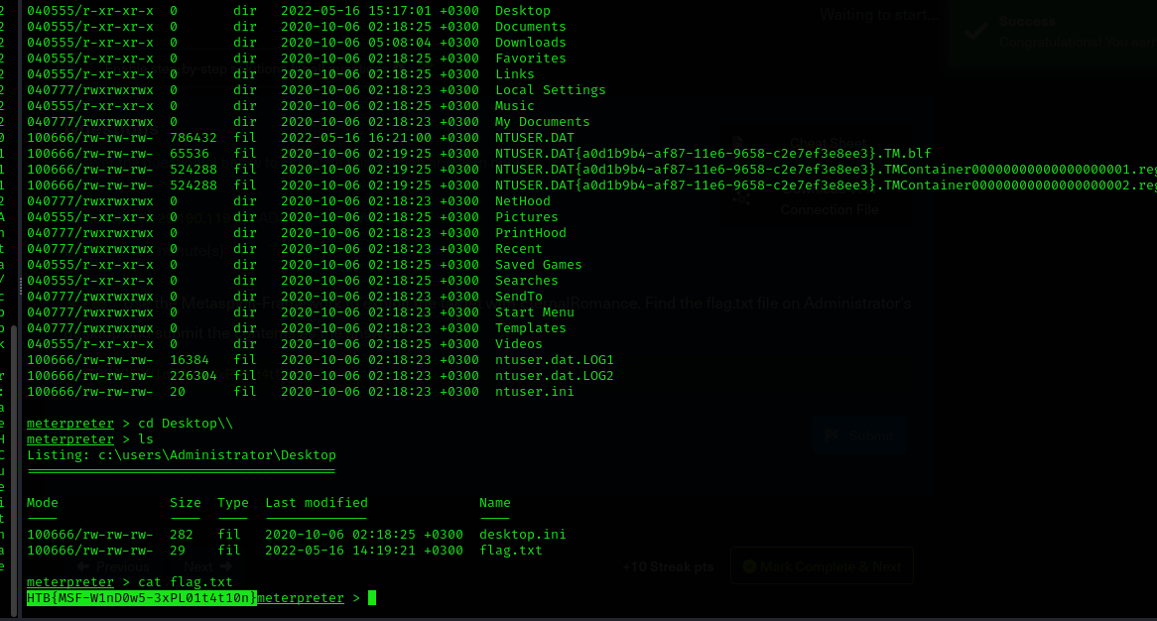
Questions
1.
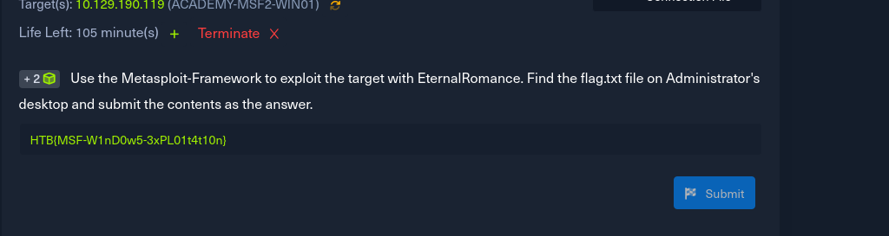

Targets
- The show target option will display all available vulnerable target for that exploit

Payloads
- This are the modules that aid the exploit. They are sent together with the payload
- A single payload contains the exploit and the entire shell code for the selected task.
- Stager payloads works together with the stage payload such that the stager waits on the attackers machine ready to establish a connection to the victim once the stage completes its run.
- Stages are payload component that are downloaded by stager’s module
- Stages payloads collaborate with stager payloads to carry out a particular task

- Meterpreter payload is a specific type of multi-faceted payload that uses DLL injection to ensure the connection to the victim host is stable

Questions
1.
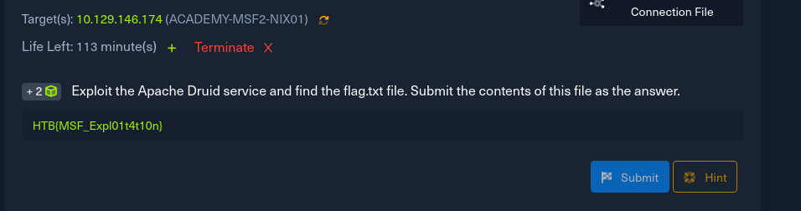
- Just like the previous exercise the first thing was to search for the exploit.
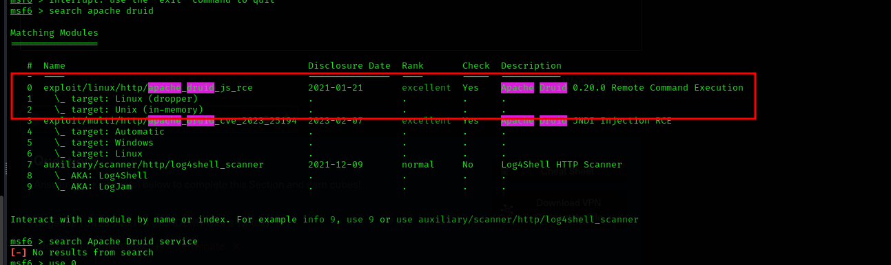
- The we pick the exploit that we are interested in
- The we configure the Lhost and lport and exploit the target
- I navigated to the root directory and finally got the flag
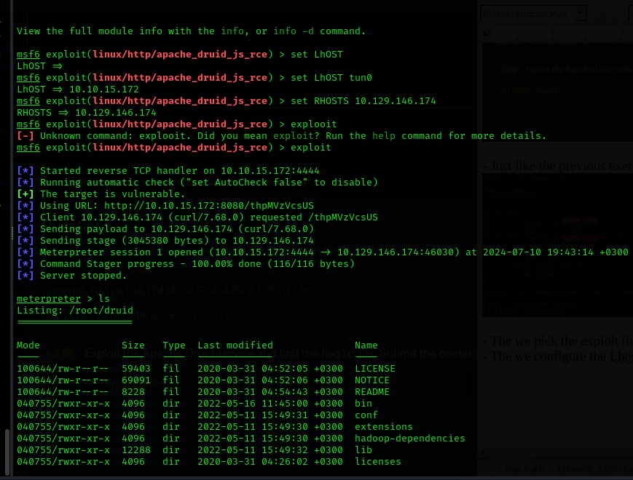

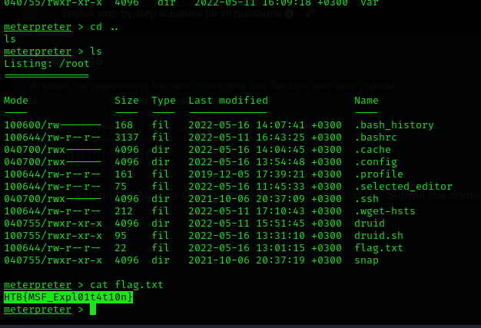

Encoders
- They help in changing payloads to run on different operating systems

Plugins
- These are readily available software that has already been used by third parties and given approval to integrate their software inside the framework

Sessions
- These creates dedicated control interfaces for all your deployed modules
- Jobs command os used to look for current active tasks running in the background
-

Questions
1.
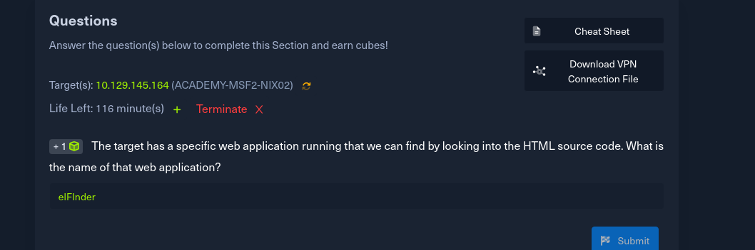
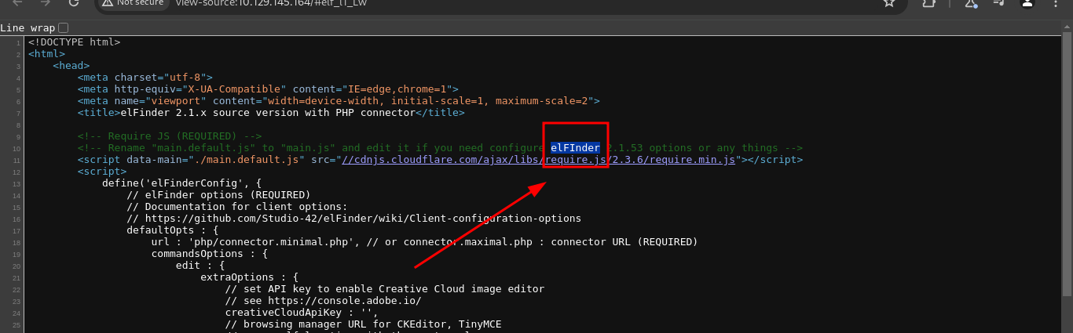
I searched for the exploit in Metesploit
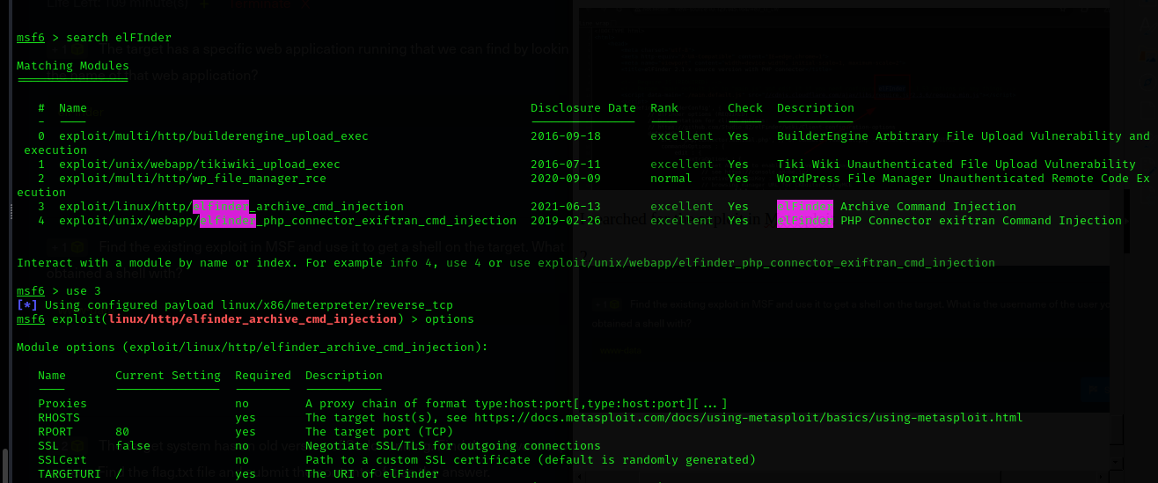

Then I configured the exploit and ran it to open the session
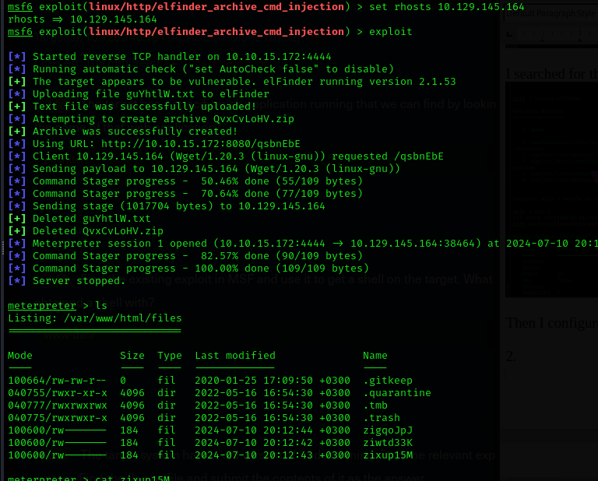

2.
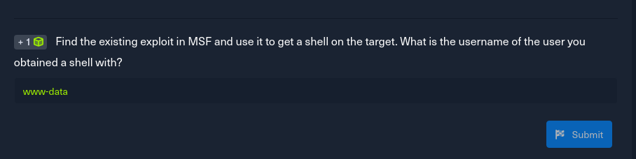
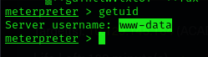

3.
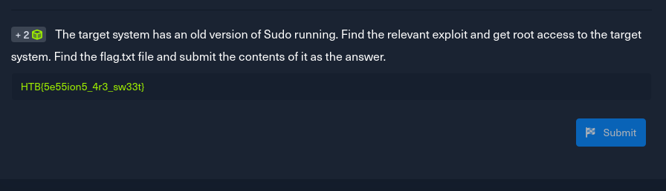
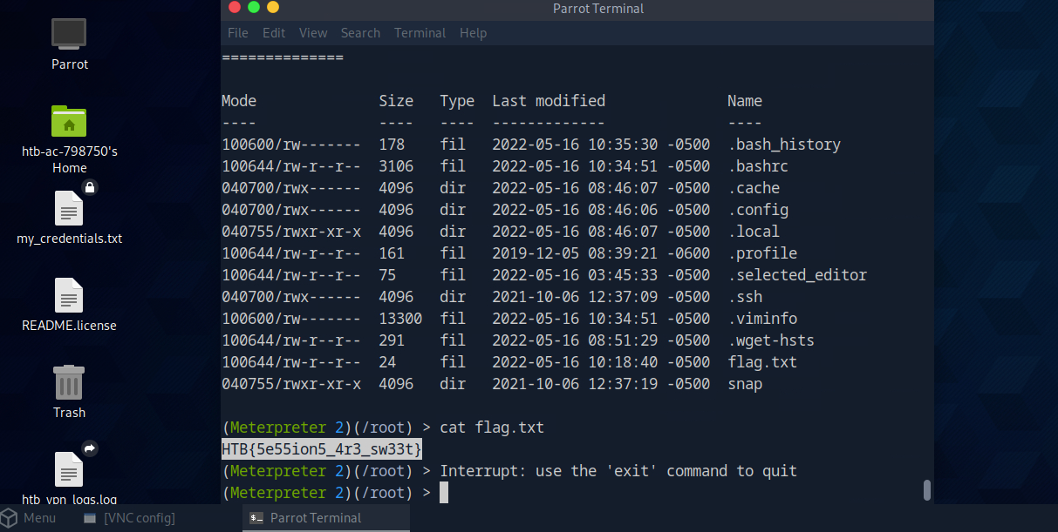
For this exercise I had to switch to the pawn box

Meterpreter
- Its an extensible payload that uses DLL Injection to ensure connection to the victim host is stable and difficult to detect

Questions
First You run Nmap to look for any open ports

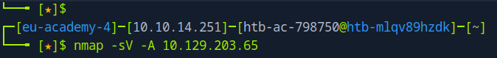
this is the results
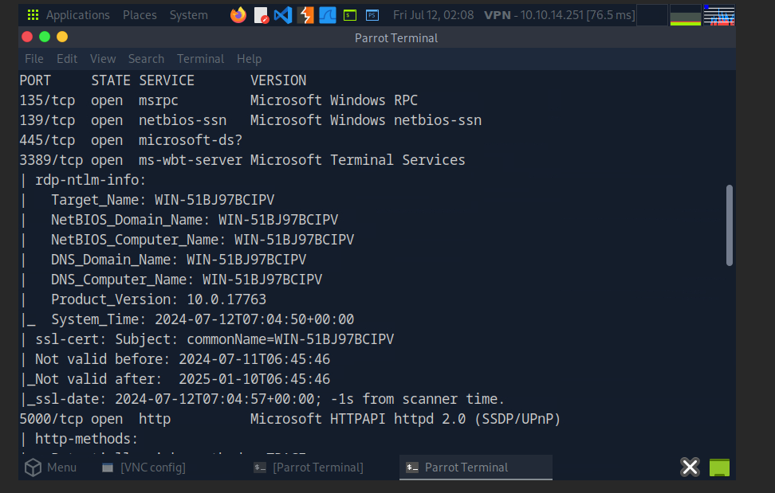
I searched for the exploit and found it

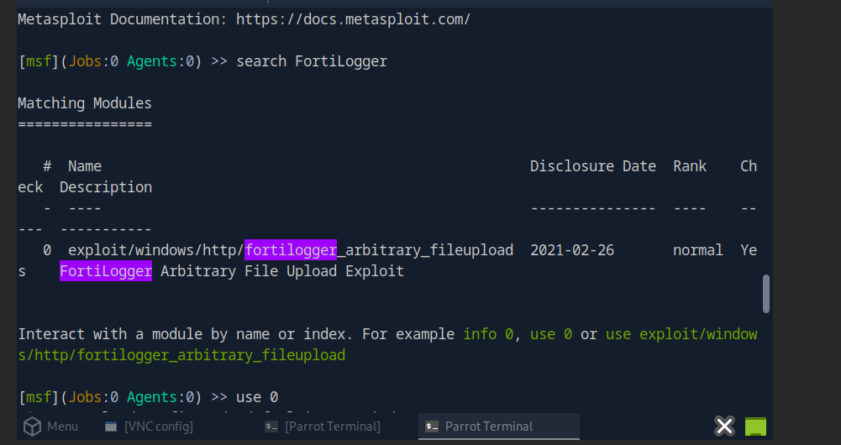
Questions
1.
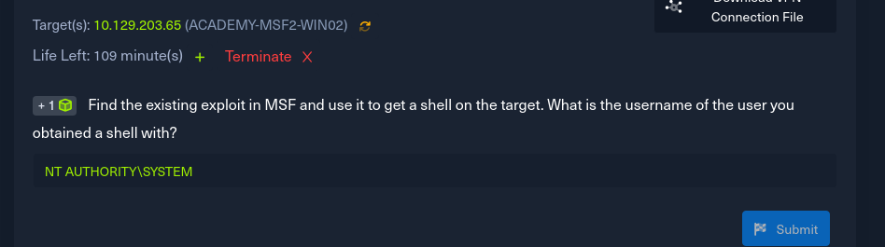
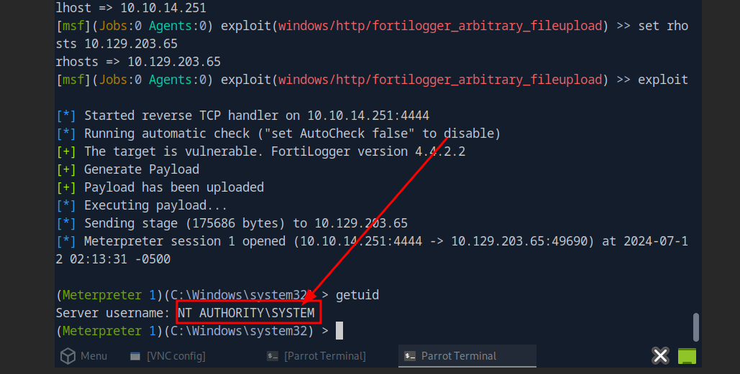
2.
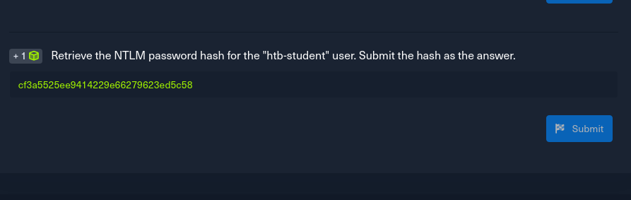
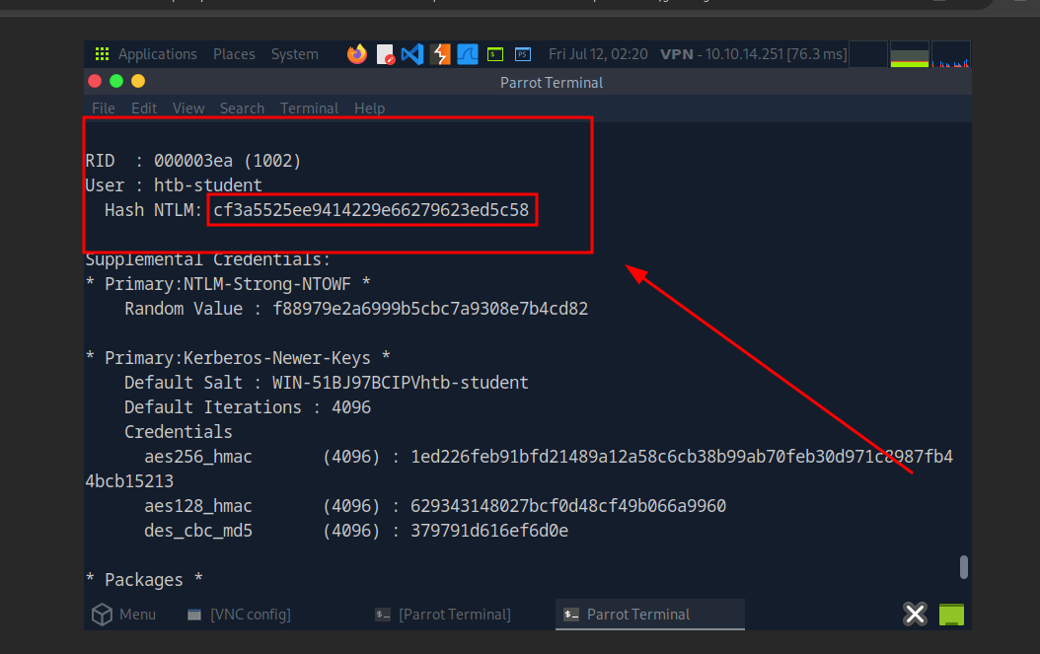
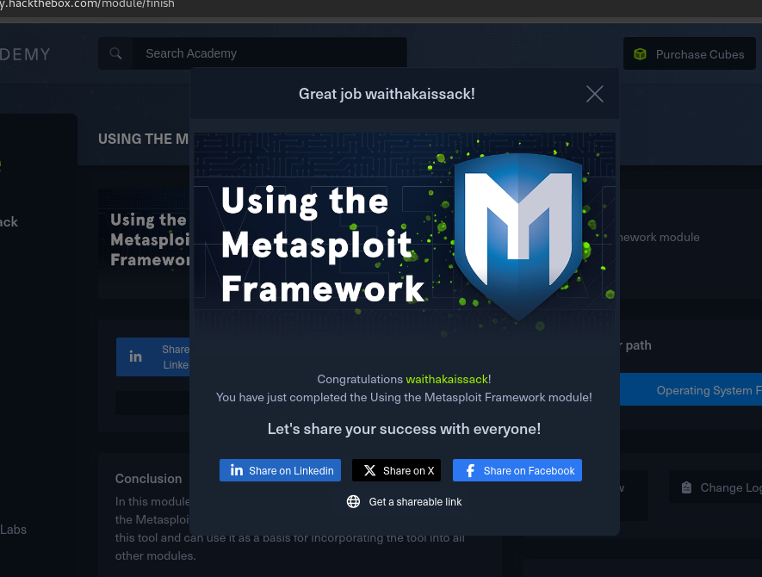
Conclusion
In this room I learnt how to use metasploit. I have learnt to search for specific exploit and run the against a target machine. It was a very interesting experience.

